

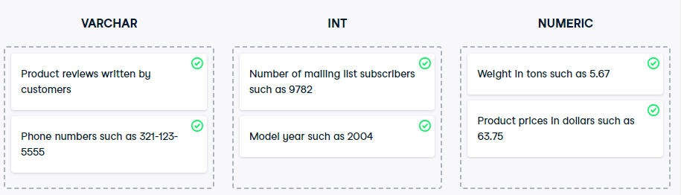

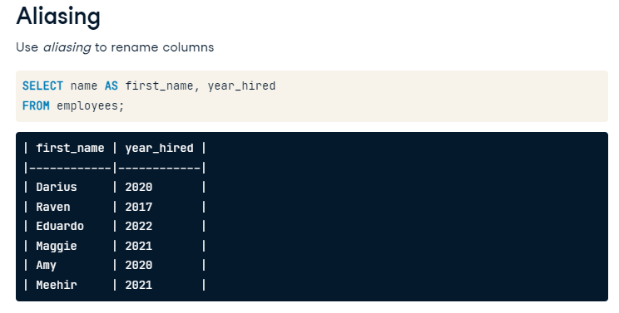

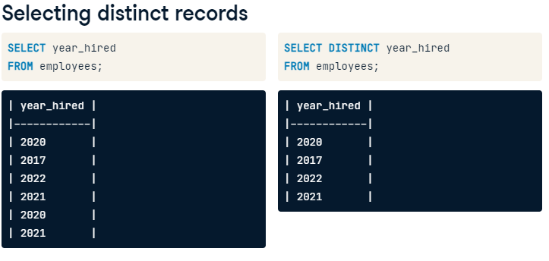

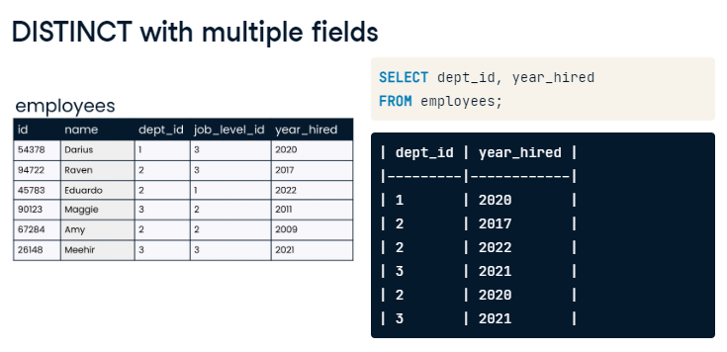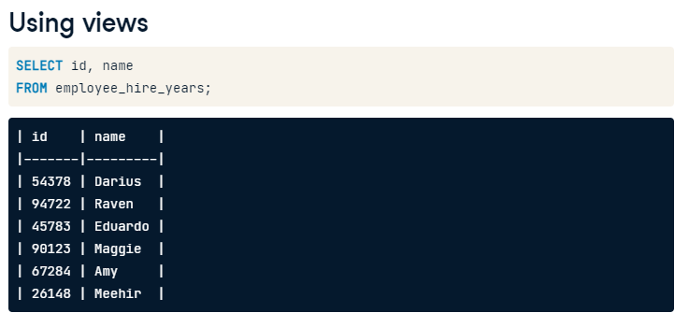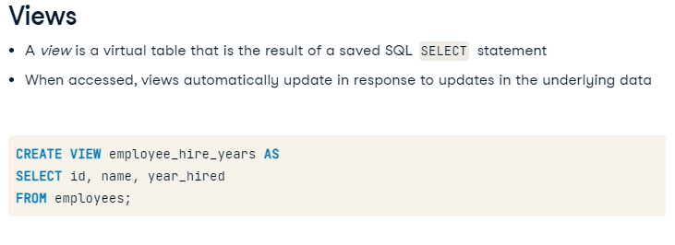

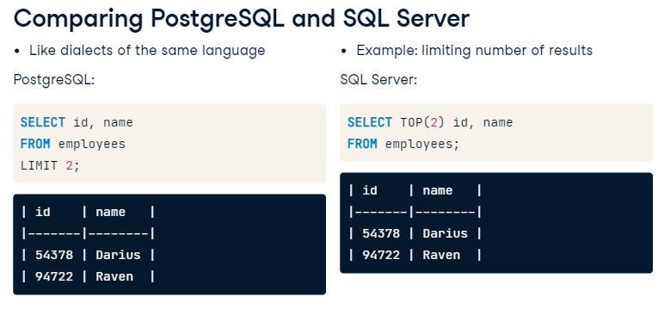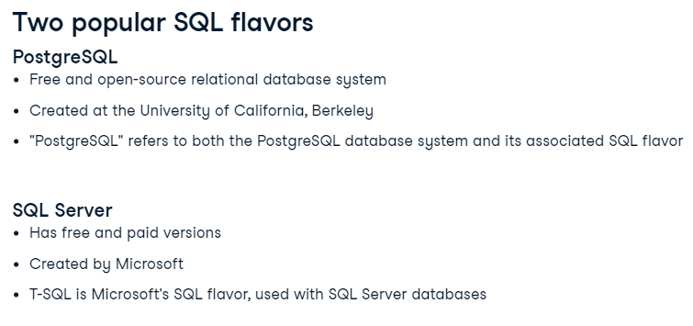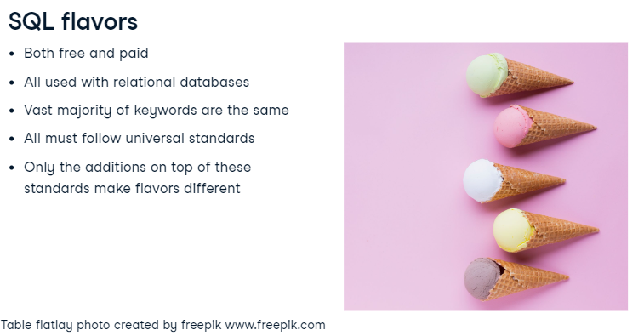

**Intermediate SQL**

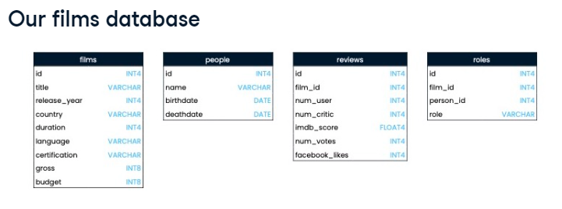****

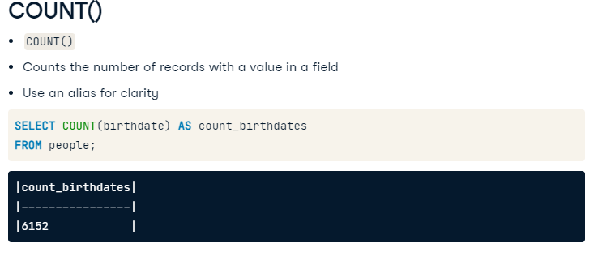

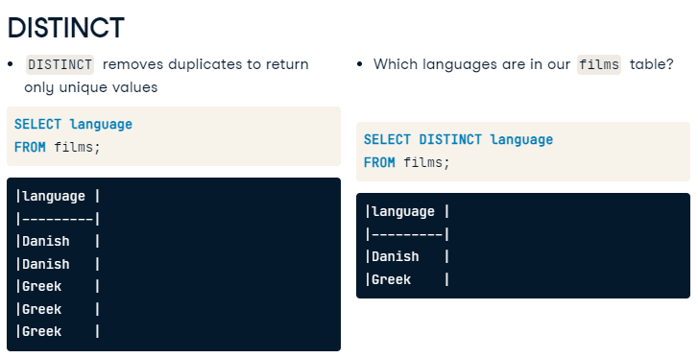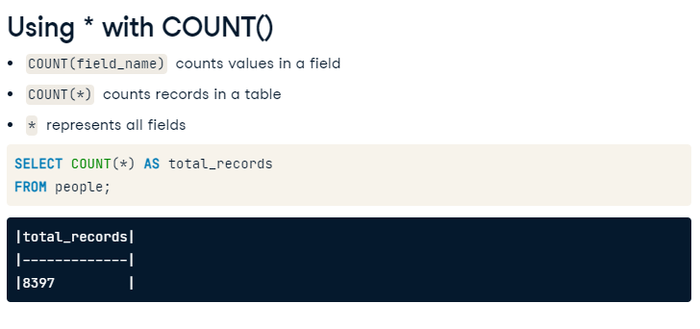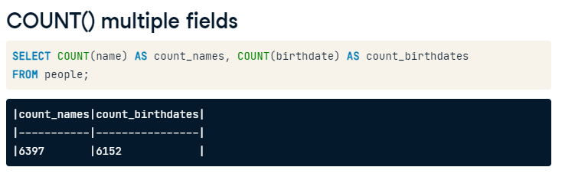

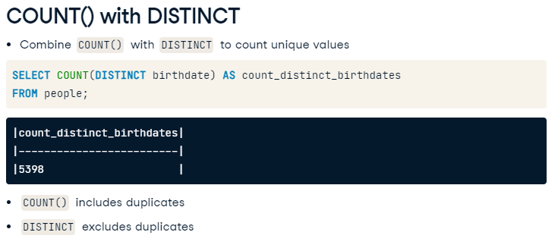-- Count the number of birthdates in the people table

select count(birthdate) as count_birthdate from people;

-- Count the records for languages and countries represented in the films table

select count(language) as count_languages , count(country) as count_countries from films;

-- Return the unique countries from the films table

select count(distinct country) as unique_countries from films;

-- Count the distinct countries from the films table

select count(distinct country) as count_distinct_countries from films;

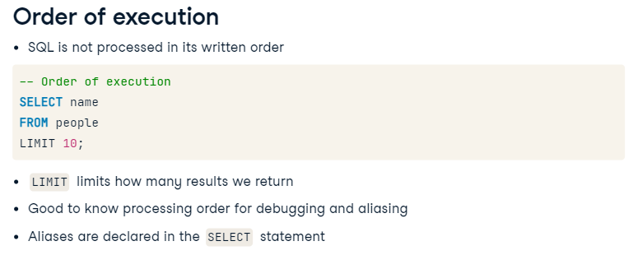

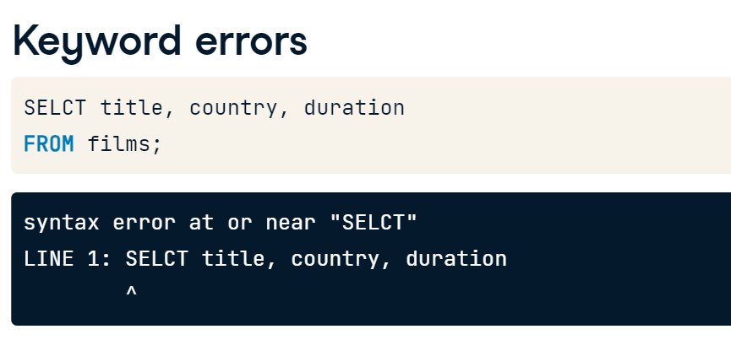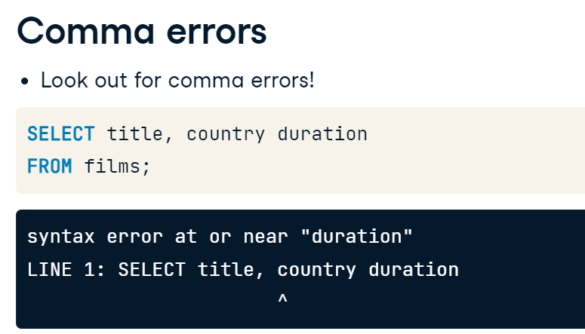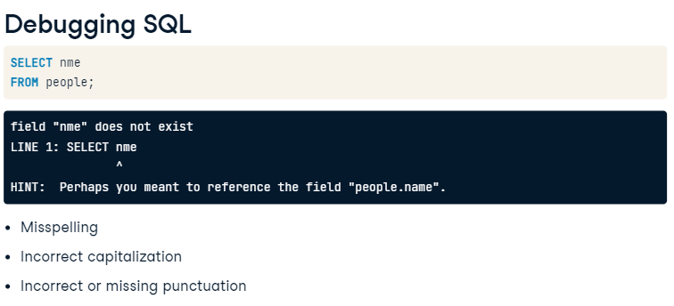

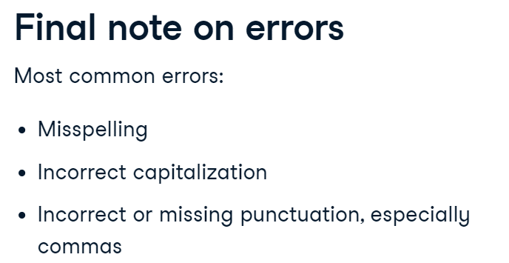

-- Debug this code

SELECT certfication

FROM films

LIMIT 5;

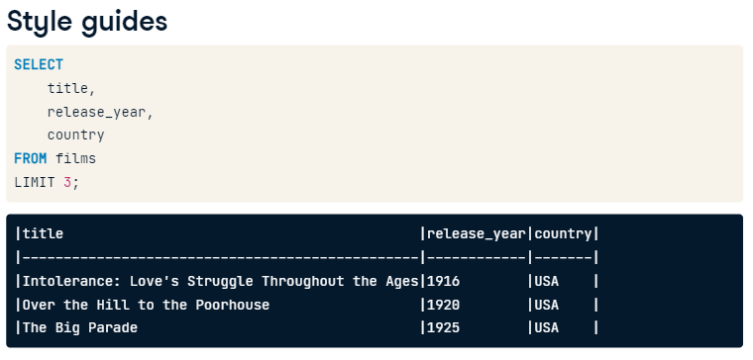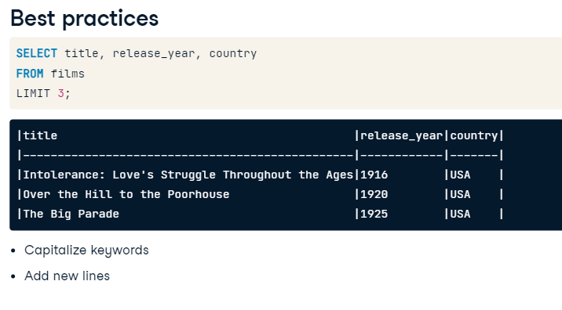

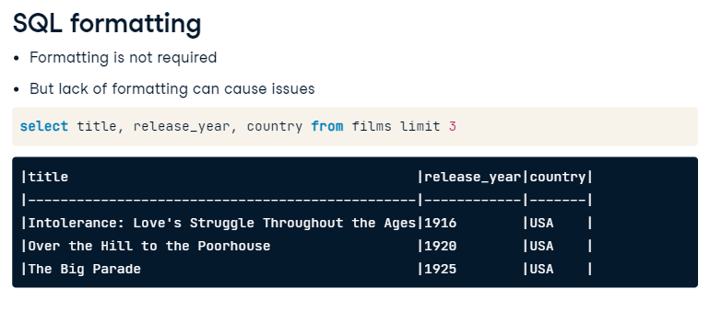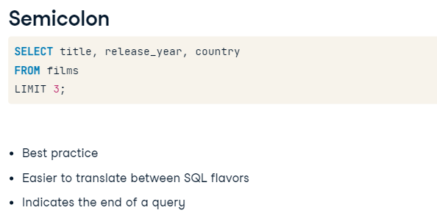

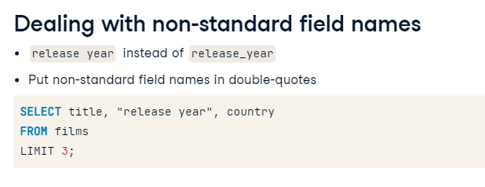





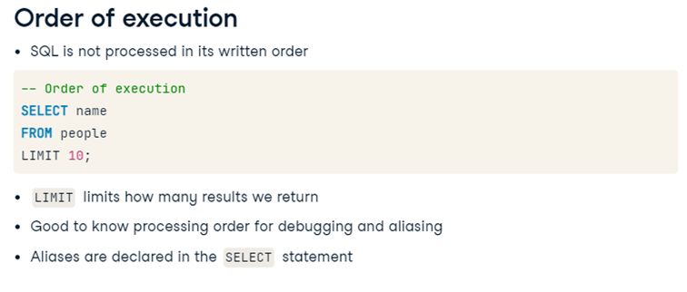

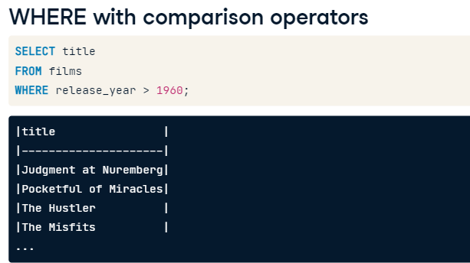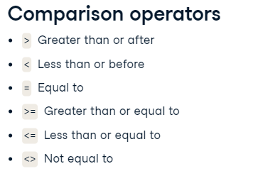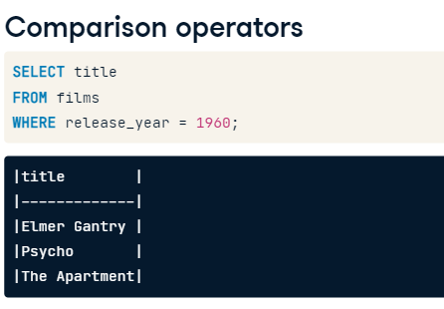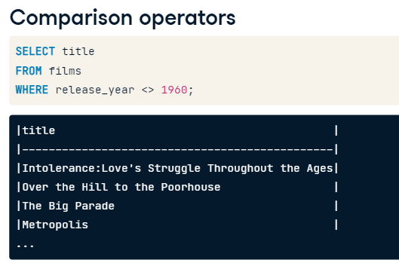

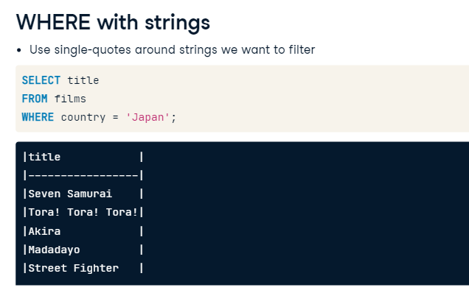

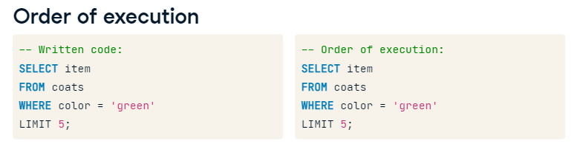

-- Select film_ids and facebook_likes for ten records with less than 1000 likes

SELECT film_id, facebook_likes FROM reviews where facebook_likes<1000 LIMIT 10;

-- Count the records with at least 100,000 votes

SELECT COUNT(*) as films_over_100k_votes FROM reviews where num_votes>= 100000;

-- Count the Spanish-language films

SELECT Count(language) as count_spanish FROM films where language = 'Spanish';

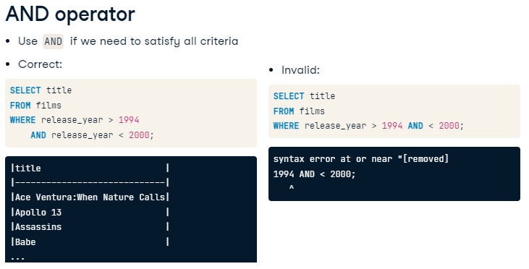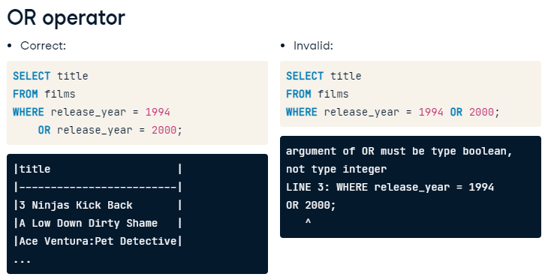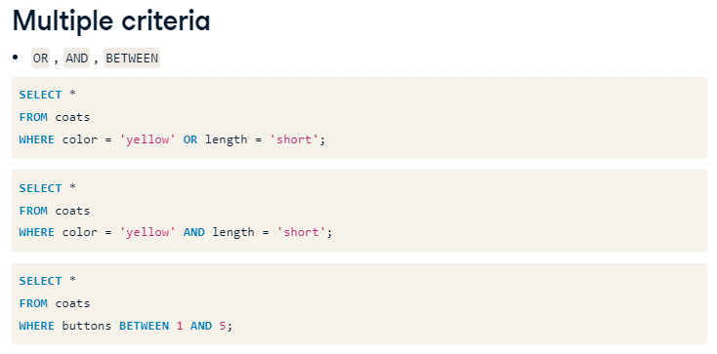

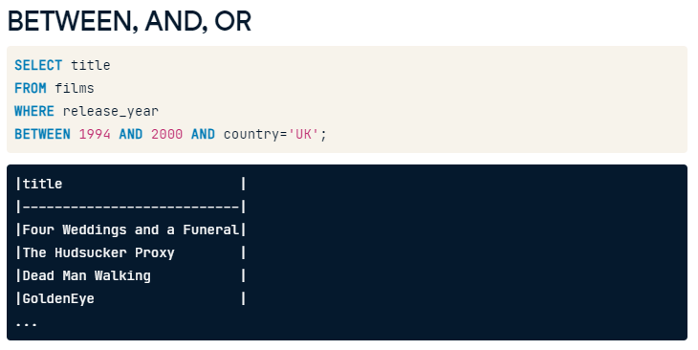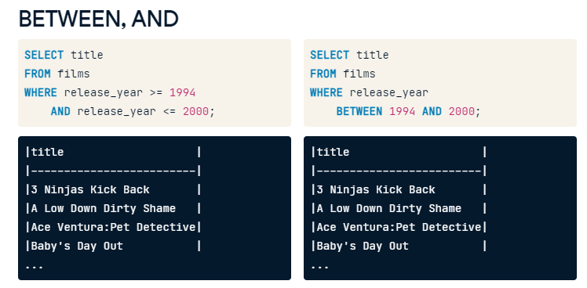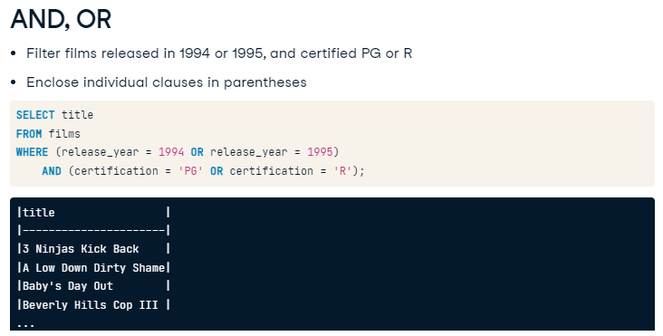

-- Select the title and release_year for all German-language films released before 2000

SELECT title, release_year FROM films WHERE language='German' AND release_year<2000;

-- Select all records for German-language films released after 2000 and before 2010

SELECT *

    FROM films

    WHERE release_year>2000 AND release_year<2010 AND language = 'German';

-- Find the title and year of films from the 1990 or 1999

SELECT title, release_year

FROM films

    WHERE ( release_year = 1990 OR release_year =1999 ) AND

            (language='English' OR language='Spanish') AND

            (gross>2000000);

SELECT title, release_year

FROM films

WHERE release_year BETWEEN 1990 AND 2000

    AND budget > 100000000

-- Restrict the query to only Spanish-language films

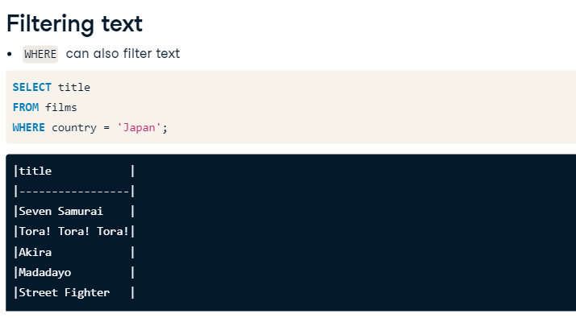    AND language = 'Spanish';

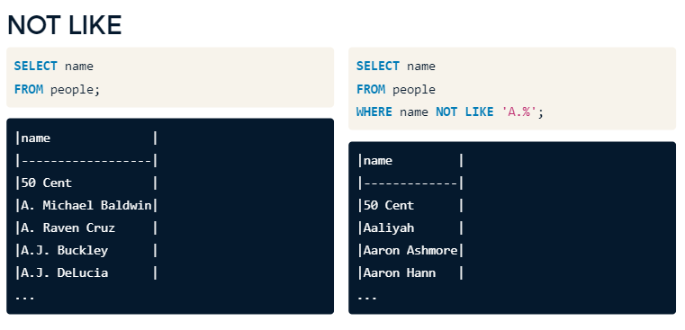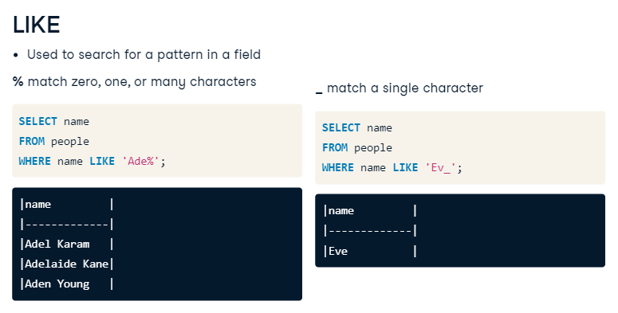

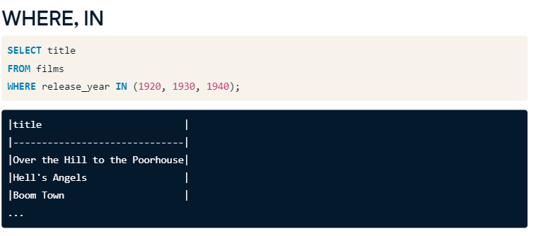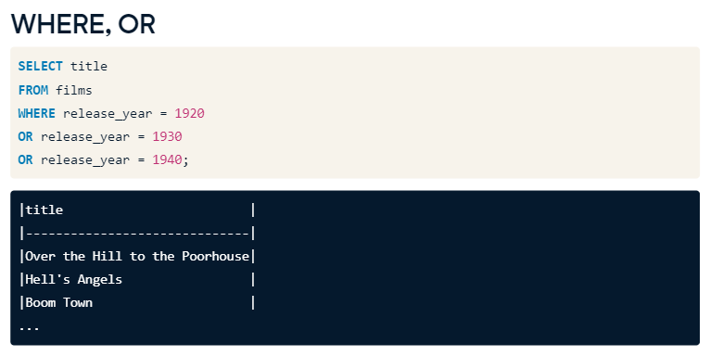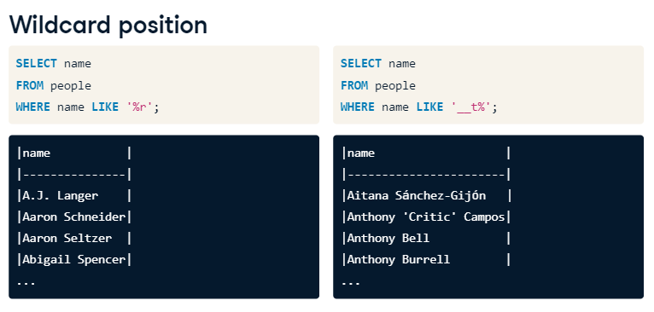

-- Select the names that start with B

SELECT name

    FROM people

    WHERE name LIKE 'B%';

-- Select the names that start with B

SELECT name

    FROM people

    WHERE name LIKE 'B%';

SELECT name

FROM people

-- Select the names that have r as the second letter

WHERE name LIKE '_r';

SELECT name

FROM people

-- Select the names that have r as the second letter

WHERE name LIKE '_r%';

SELECT name

FROM people

-- Select names that don't start with A

WHERE name NOT LIKE 'A%';

-- Find the title and release_year for all films over two hours in length released in 1990 and 2000

SELECT title, release_year

        FROM films

        WHERE release_year in(1990,2000) AND duration>120;

-- Find the title and language of all films in English, Spanish, and French

SELECT title, language

    FROM films

    WHERE language in('English','Spanish','French')

-- Find the title, certification, and language all films certified NC-17 or R that are in English, Italian, or Greek

SELECT title, certification, language

        FROM films

        WHERE language in('English','Italian','Greek')

        AND certification in ('NC-17','R');

* Count the unique titles from the films database and use the alias provided.
* Filter to include only movies with a release_year from 1990 to 1999, inclusive.
* Add another filter narrowing your query down to English-language films.
* Add a final filter to select only films with 'G', 'PG', 'PG-13' certifications.
* -- Count the unique titles
* SELECT Count(DISTINCT title) AS nineties_english_films_for_teens
* FROM films
* -- Filter to release_years to between 1990 and 1999
* WHERE release_year between 1990 and 1999
* -- Filter to English-language films
* AND language = 'English'
* -- Narrow it down to G, PG, and PG-13 certifications
* AND certification in ('G','PG','PG-13');

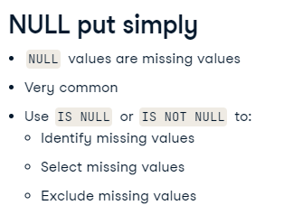****

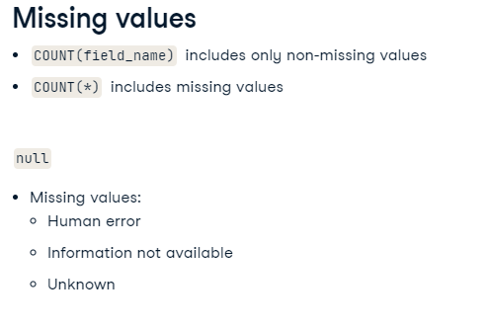

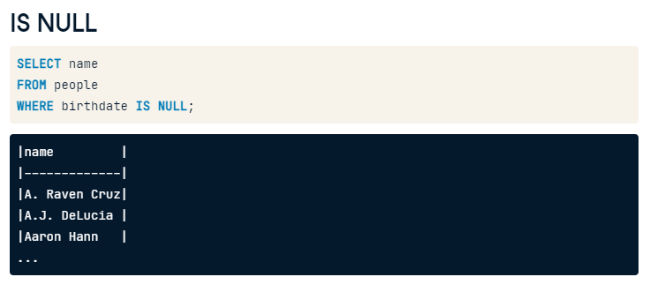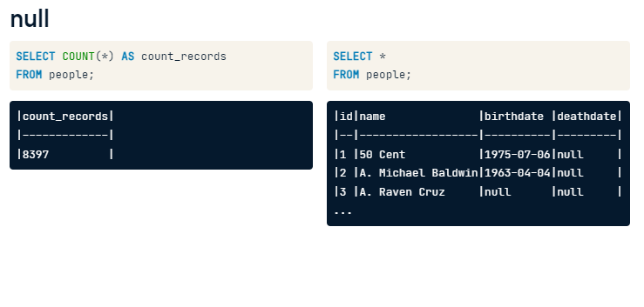

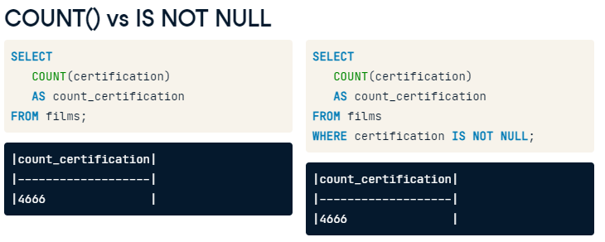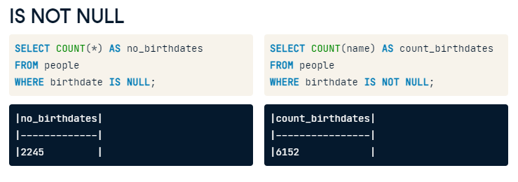

-- List all film titles with missing budgets

SELECT title as no_budget_info

    FROM films

    WHERE budget is null;

    -- List all film titles with missing budgets

-- Count the number of films we have language data for

--SELECT Count(title) as count_language_known1

    --FROM films;

SELECT Count(title) as count_language_known2

    FROM films

    WHERE language is not null;

**Aggregate functions are**

**Placed after the SELECT keyword.**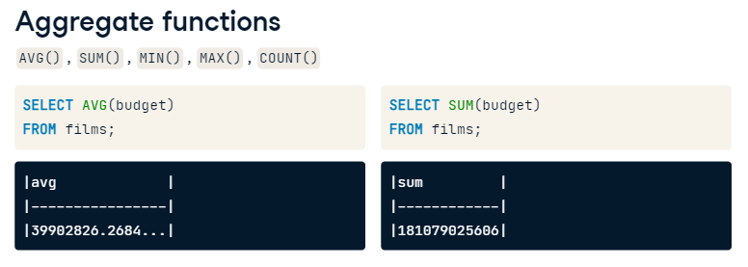

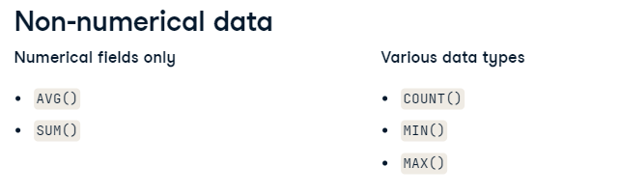

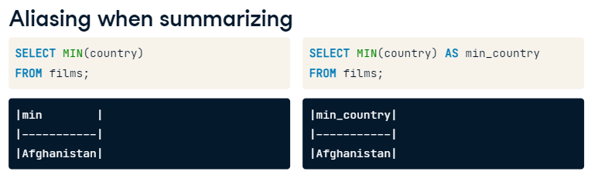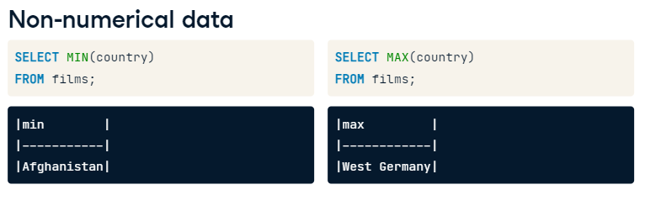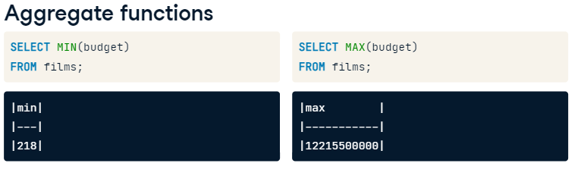

* **Use the SUM() function to calculate the total duration of all films and alias with total_duration.**
* -- Query the sum of film durations
* SELECT sum(duration) as total_duration
* FROM films;
* **Calculate the average duration of all films and alias with average_duration.**
* -- Calculate the average duration of all films
* SELECT AVG(duration) as average_duration
* FROM films;

-- Find the latest release_year

SELECT MAX(release_year) as latest_year

    FROM films;

* **Find the duration of the shortest film and use the alias shortest_film.**
* -- Find the duration of the shortest film
* SELECT Min(duration) as shortest_film
* FROM films;
* 

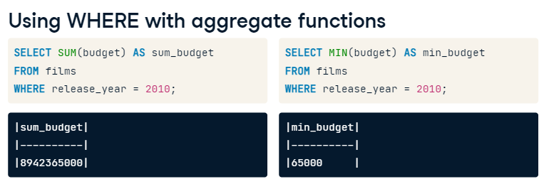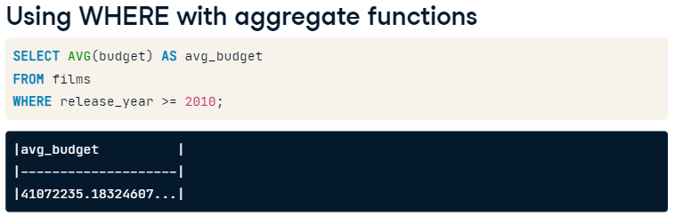

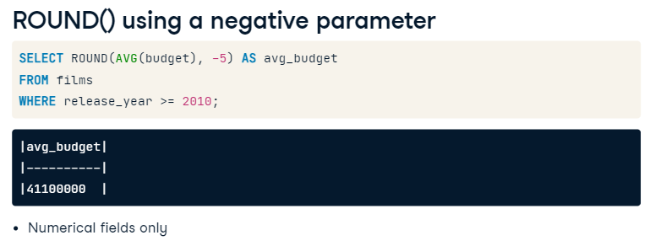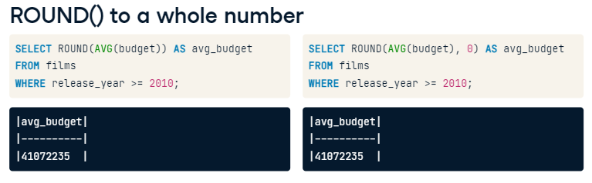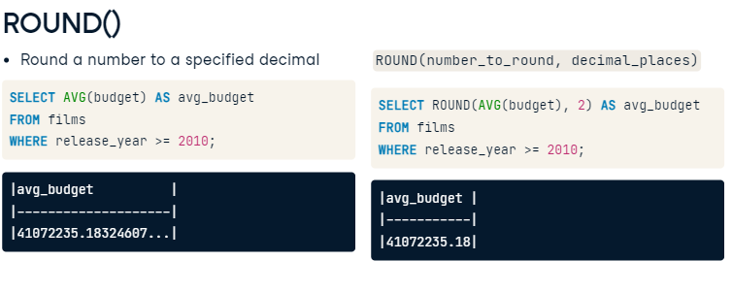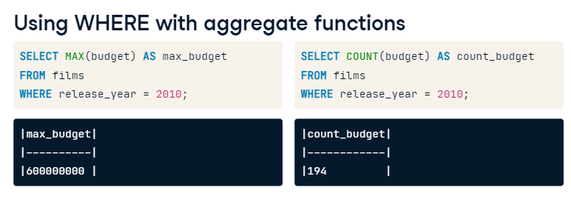

* Use SUM() to calculate the total gross for all films made in the year 2000 or later, and use the alias total_gross.
* -- Calculate the sum of gross from the year 2000 or later
* SELECT SUM(gross) as total_gross
* FROM films
* WHERE release_year >=2000;
* Calculate the average amount grossed by all films whose titles start with the letter 'A' and alias with avg_gross_A.

-- Calculate the average gross of films that start with A

SELECT AVG(gross) as avg_gross_A

    FROM films

    WHERE title  like 'A%';

* Calculate the lowest gross film in 1994 and use the alias lowest_gross.
* -- Calculate the lowest gross film in 1994
* SELECT MIN(gross) as lowest_gross
* FROM films
* WHERE release_year = 1994;
* Calculate the highest gross film between 2000 and 2012, inclusive, and use the alias highest_gross.

-- Calculate the highest gross film released between 2000-2012

SELECT MAX(gross) as highest_gross

    FROM films

    WHERE release_year

    between 2000 AND 2012;

**Using ROUND()**

Aggregate functions work great with numerical values; however, these results can sometimes get unwieldy when dealing with long decimal values. Luckily, SQL provides you with the ROUND() function to tame these long decimals.

If asked to give the average budget of your films, ten decimal places is not necessary. Instead, you can round to two decimal places to create results that make more sense for currency.

Now you try!

* Calculate the average facebook_likes to one decimal place and assign to the alias, avg_facebook_likes.
* -- Round the average number of facebook_likes to one decimal place
* --WRONG ONE
* SELECT AVG(Round(facebook_likes,1)) as avg_facebook_likes
* FROM reviews;

-- Round the average number of facebook_likes to one decimal place

--RIGHT ONE

SELECT ROUND(AVG(facebook_likes),1) as avg_facebook_likes

    FROM reviews;

* Calculate the average budget from the films table, aliased as avg_budget_thousands, and round to the nearest thousand.
* -- Calculate the average budget rounded to the thousands
* SELECT ROUND(AVG(budget)/1000)*1000 as avg_budget_thousands
* FROM films;



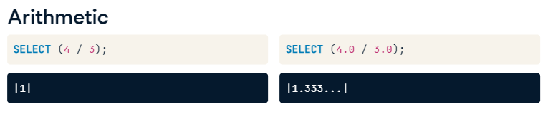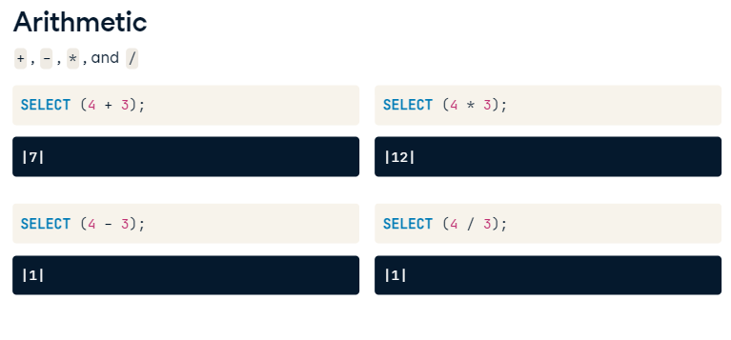

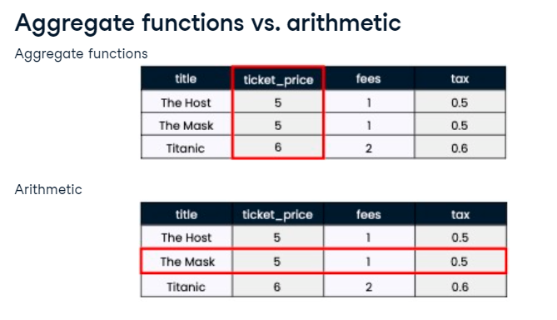 **Aggregate: Works Vertically, Arithmetic: Works horizontally.** 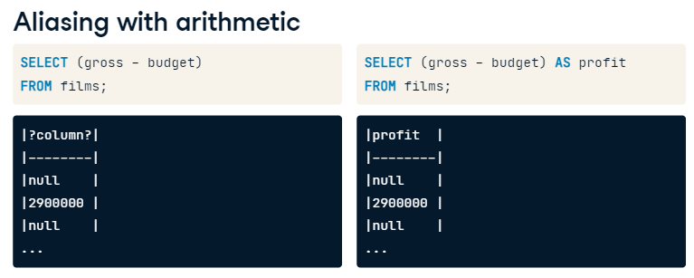

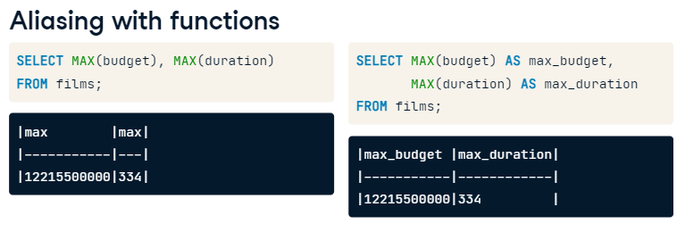

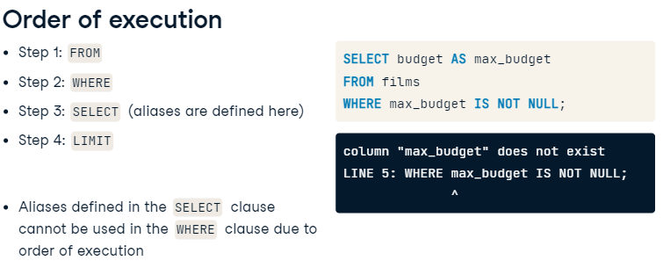

# You have seen that SQL can act strangely when dividing integers. What is the result if you divide a discount of two dollars by the paid_price of ten dollars to get the discount percentage?

# Aliasing with functions

Aliasing can be a lifesaver, especially as we start to do more complex SQL queries with multiple criteria. Aliases help you keep your code clean and readable. For example, if you want to find the MAX() value of several fields without aliasing, you'll end up with the result with several columns called max and no idea which is which. You can fix this with aliasing.

Now, it's over to you to clean up the following queries.

* **Select the title and duration in hours for all films and alias as duration_hours; since the current durations are in minutes, you'll need to divide duration by 60.0.**

-- Calculate the title and duration_hours from films

SELECT title, (duration/60) as duration_hours

    FROM films;

Note the double and integer difference.

-- Calculate the title and duration_hours from films

SELECT title, (duration/60.0) as duration_hours

    FROM films;

* **Calculate the percentage of people who are no longer alive and alias the result as percentage_dead.**
* -- Calculate the percentage of people who are no longer alive
* SELECT COUNT(deathdate) * 100.0 /COUNT(*) AS percentage_dead
* FROM people;
* Find how many decades (period of ten years) the films table covers by using MIN() and MAX(); alias as number_of_decades.
* -- Find the number of decades in the films table
* SELECT (MAX(release_year) - MIN(release_year)) / 10 AS number_of_decades
* FROM films;



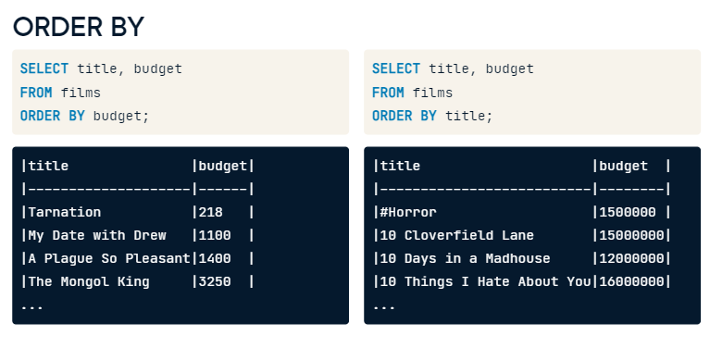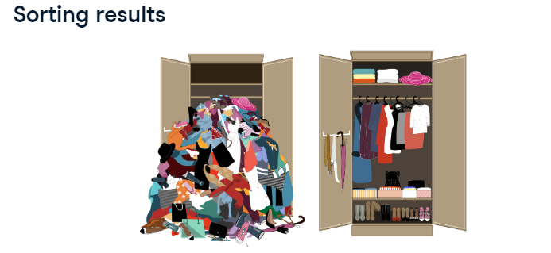

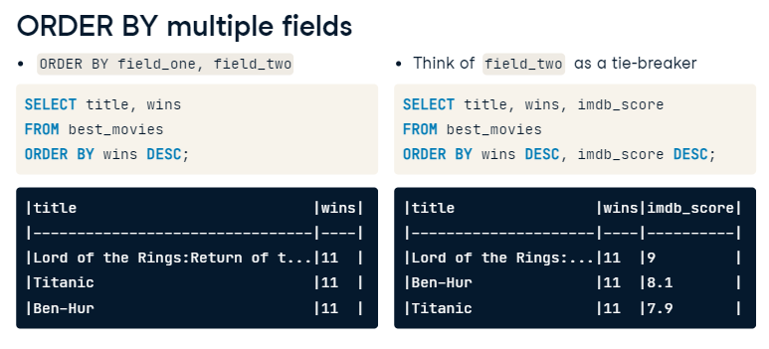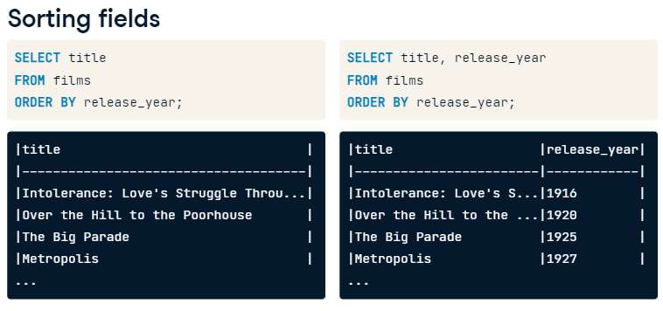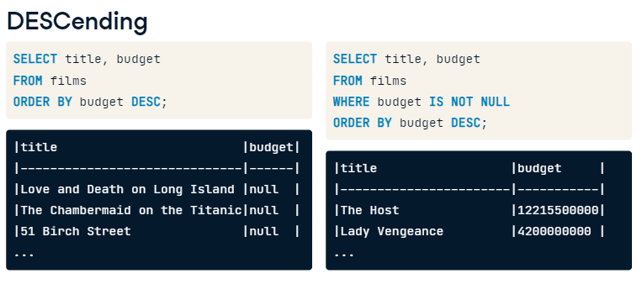

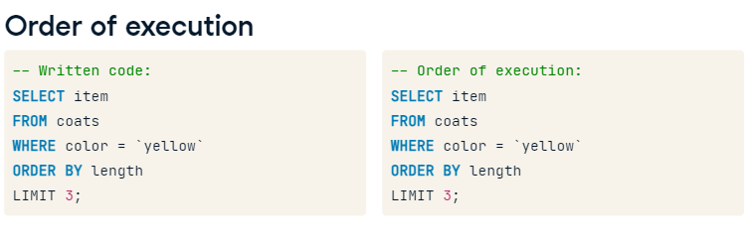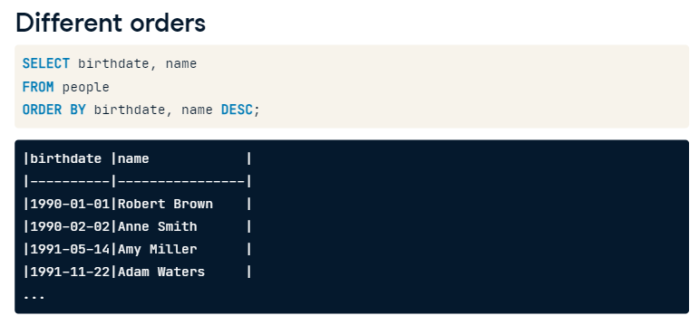

# Sorting single fields

Now that you understand how ORDER BY works, you'll put it into practice. In this exercise, you'll work on sorting single fields only. This can be helpful to extract quick insights such as the top-grossing or top-scoring film.

The following exercises will help you gain further insights into the film database.

* Select the name of each person in the people table, sorted alphabetically.
* -- Select name from people and sort alphabetically
* SELECT name
* FROM people
* ORDER BY name ;
* Select the title and duration for every film, from longest duration to shortest.
* -- Select the title and duration from longest to shortest film
* SELECT title, duration
* FROM films
* ORDER BY duration DESC;

# Sorting multiple fields

ORDER BY can also be used to sort on multiple fields. It will sort by the first field specified, then sort by the next, and so on. As an example, you may want to sort the people data by age and keep the names in alphabetical order.

Try using ORDER BY to sort multiple columns.

* Select the release_year, duration, and title of films ordered by their release year and duration, in that order.
* -- Select the release year, duration, and title sorted by release year and duration
* SELECT release_year, duration, title
* FROM films
* ORDER BY release_year,duration;
* Select the certification, release_year, and title from films ordered first by certification (alphabetically) and second by release year, starting with the most recent year.

-- Select the certification, release year, and title sorted by certification and release year

Select certification, release_year, title

    FROM films

    ORDER BY certification, release_year DESC;



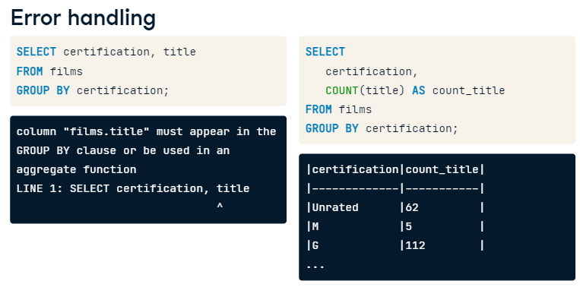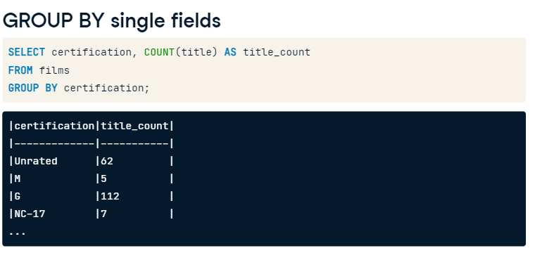

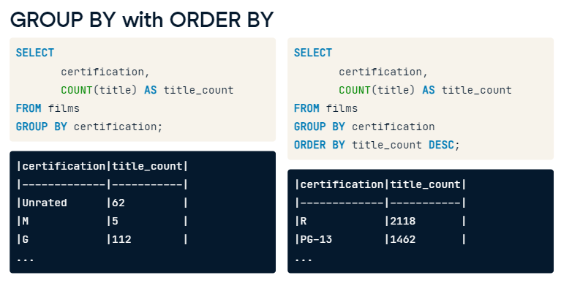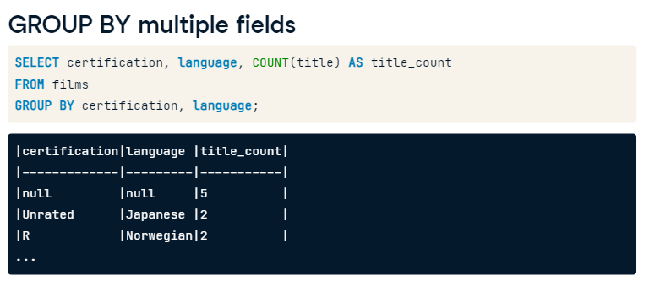

# GROUP BY single fields

GROUP BY is a SQL keyword that allows you to group and summarize results with the additional use of aggregate functions. For example, films can be grouped by the certification and language before counting the film titles in each group. This allows you to see how many films had a particular certification and language grouping.

In the following steps, you'll summarize other groups of films to learn more about the films in your database.

* Select the release_year and count of films released in each year aliased as film_count.
* -- Find the release_year and film_count of each year
* SELECT release_year, count(title) as film_count
* FROM films
* GROUP BY release_year;
* Select the release_year and average duration aliased as avg_duration of all films, grouped by release_year.

-- Find the release_year and average duration of films for each year

SELECT release_year, Round(AVG(duration),4) as avg_duration

    FROM films

    GROUP BY release_year;

# GROUP BY multiple fields

GROUP BY becomes more powerful when used across multiple fields or combined with ORDER BY and LIMIT.

Perhaps you're interested in learning about budget changes throughout the years in individual countries. You'll use grouping in this exercise to look at the maximum budget for each country in each year there is data available.

* Select the release_year, country, and the maximum budget aliased as max_budget for each year and each country; sort your results by release_year and country.

-- Find the release_year, country, and max_budget, then group and order by release_year and country

SELECT release_year as release_year, country as country, MAX(budget) as max_budget

    FROM films

    group by release_year, country

    order by release_year, country;

# Answering business questions

In the real world, every SQL query starts with a business question. Then it is up to you to decide how to write the query that answers the question. Let's try this out.

Which release_year had the most language diversity?

Take your time to translate this question into code. We'll get you started then it's up to you to test your queries in the console.

"Most language diversity" can be interpreted as COUNT(DISTINCT ___). Now over to you.

SELECT distinct release_year, count(distinct language) as language_diversity

    FROM films

    group by release_year

    order by language_diversity

    limit 1;

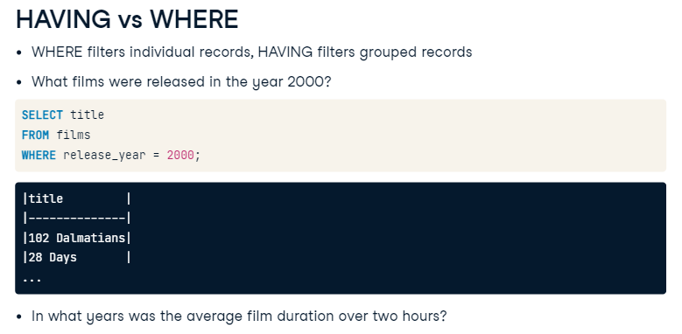

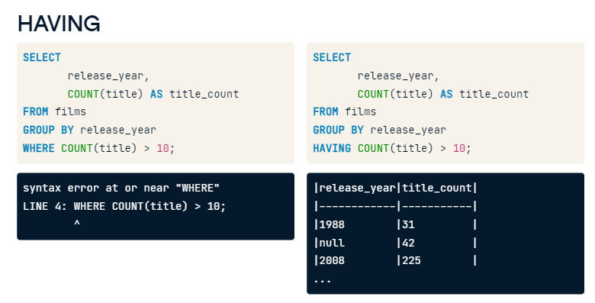

# Filter with HAVING

Your final keyword is HAVING. It works similarly to WHERE in that it is a filtering clause, with the difference that HAVING filters grouped data.

Filtering grouped data can be especially handy when working with a large dataset. When working with thousands or even millions of rows, HAVING will allow you to filter for just the group of data you want, such as films over two hours in length!

Practice using HAVING to find out which countries (or country) have the most varied film certifications.

* Select country from the films table, and get the distinct count of certification aliased as certification_count.
* -- Select the country and distinct count of certification as certification_count
* SELECT country, count(distinct certification) as certification_count
* FROM films
* -- Group by country
* Group by country
* -- Filter results to countries with more than 10 different certifications
* HAVING count(certification) > 10 ;

State the difference

-- Select the country and distinct count of certification as certification_count

SELECT country, count(distinct certification) as certification_count

    FROM films

-- Group by country

    Group by country

-- Filter results to countries with more than 10 different certifications

    HAVING count(distinct certification) > 10 ;

# HAVING and sorting

Filtering and sorting go hand in hand and gives you greater interpretability by ordering our results.

Let's see this magic at work by writing a query showing what countries have the highest average film budgets.

* Select the country and the average budget as average_budget, rounded to two decimal, from films.
* Group the results by country.
* Filter the results to countries with an average budget of more than one billion (1000000000).
* Sort by descending order of the average_budget.
* -- Select the country and average_budget from films
* SELECT country, Round(avg(budget),2) as average_budget
* FROM films
* -- Group by country
* Group by country
* -- Filter to countries with an average_budget of more than one billion
* Having AVG(average_budget) > 1000000000
* -- Order by descending order of the aggregated budget
* ORDER by average_budget desc ;

-- Select the country and average_budget from films

SELECT country, Round(avg(budget),2) as average_budget

        FROM films

-- Group by country

    Group by country

-- Filter to countries with an average_budget of more than one billion

    Having AVG(budget) > 1000000000

-- Order by descending order of the aggregated budget

    ORDER by average_budget desc ;

# All together now

It's time to use much of what you've learned in one query! This is good preparation for using SQL in the real world where you'll often be asked to write more complex queries since some of the basic queries can be answered by playing around in spreadsheet applications.

In this exercise, you'll write a query that returns the average budget and gross earnings for films each year after 1990 if the average budget is greater than 60 million.

This will be a big query, but you can handle it!

* Select the release_year for each film in the films table, filter for records released after 1990, and group by release_year.

-- Select the release_year for films released after 1990 grouped by year

SELECT release_year

    FROM films

    Group by release_year

    having release_year>1990;

* Modify the query to include the average budget aliased as avg_budget and average gross aliased as avg_gross for the results we have so far.
* -- Modify the query to also list the average budget and average gross
* SELECT release_year, AVG(budget) as average_budget, AVG(gross) as avg_gross
* FROM films
* WHERE release_year > 1990
* GROUP BY release_year;

-- Modify the query to also list the average budget and average gross

SELECT release_year, AVG(budget) as avg_budget, AVG(gross) as avg_gross

FROM films

WHERE release_year > 1990

GROUP BY release_year;

* Modify the query once more so that only years with an average budget of greater than 60 million are included.
* SELECT release_year, AVG(budget) AS avg_budget, AVG(gross) AS avg_gross
* FROM films
* WHERE release_year > 1990
* GROUP BY release_year
* -- Modify the query to see only years with an avg_budget of more than 60 million
* Having Avg(budget)>=60000000;
* Finally, order the results from the highest average gross and limit to one.
* SELECT release_year, AVG(budget) AS avg_budget, AVG(gross) AS avg_gross
* FROM films
* WHERE release_year > 1990
* GROUP BY release_year
* HAVING AVG(budget) > 60000000
* -- Order the results from highest to lowest average gross and limit to one
* ORDER BY avg_gross desc
* limit 1;

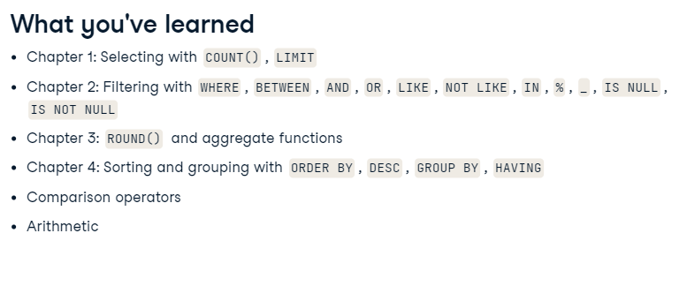





Joining Data In SQL(09/09/23)